**1.User Login Page:**

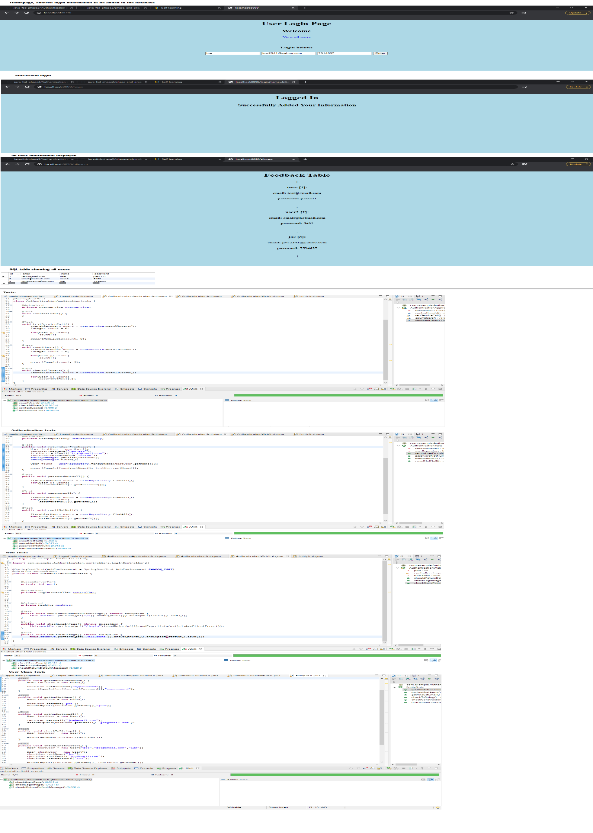

**2.After the user successfully logs in:**



**3.Feedback Table containing the users information:**

